Guide to GitHub (Desktop Version) for MIL Electrical

Introduction
GitHub is an online platform for version control. This guide will explain one way to use GitHub that has been tested to work smoothly with Altium Designer.

Step 1: Installation
While GitHub is a website, it is intended to be used in conjunction with software for your computer called Git. Follow these instructions to install Git.

Visit https://desktop.github.com/ and download the installer. Run the installer. Leave everything as default.

Note: It will be useful to show file extensions in Windows. You can find the setting by clicking “View” and enable this feature:
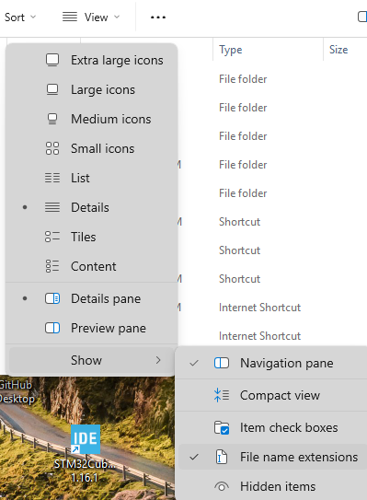

Step 2) SVN Legacy Clone
Before you can start your own project you need to first obtain some files that may be useful. Namely, the PCB design libraries are located in a special repository named “SVN Legacy”. This step will show you how to set those files up in your work environment.

- Create a folder named “MIL” on your PC
- Create a subfolder named “SVN Legacy” under the “MIL” folder
- Clone the SVN Legacy Repository to your local “SVN Legacy” folder
  - Go to SVN Legacy Repo Site: https://github.com/uf-mil-electrical/SVN-Legacy
  - Click the “Clone or download” drop down button and then click “Open in Desktop”

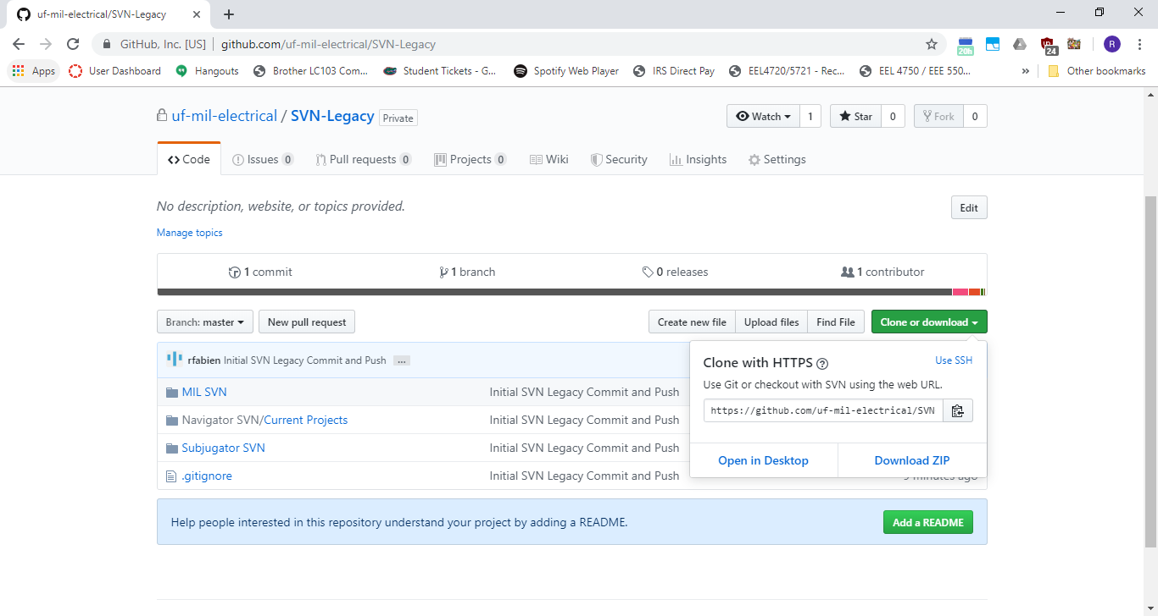
  - Click the “Open GitHubDesktop.exe” button and click the check box as well so this process does not have to be repeated in the future.

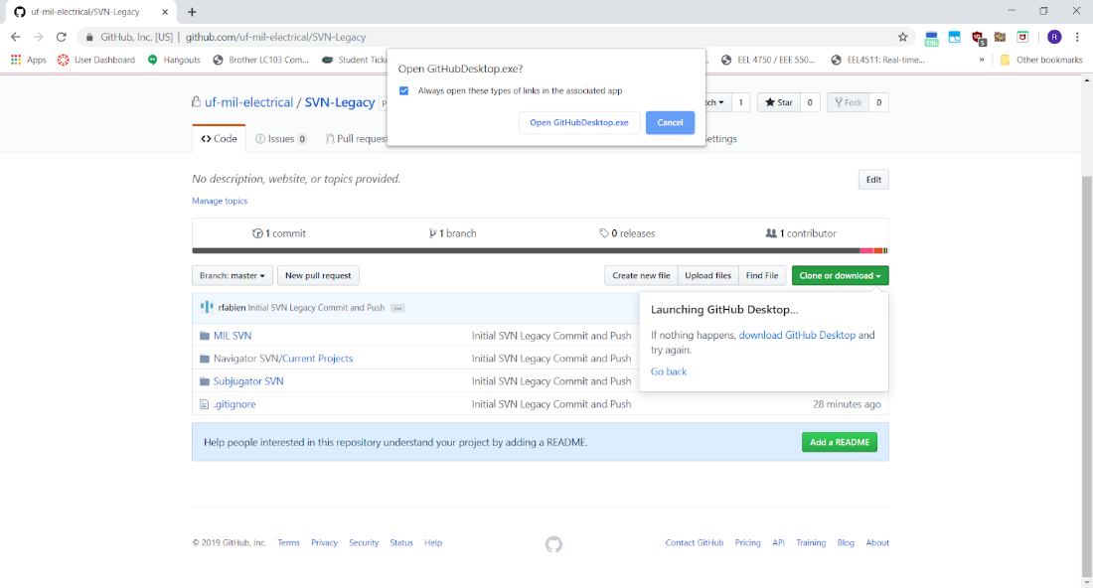

  - The GitHub Desktop app should now pop up with a “Clone a repository” window. Change the local path to the “SVN Legacy” subfolder and then click clone.

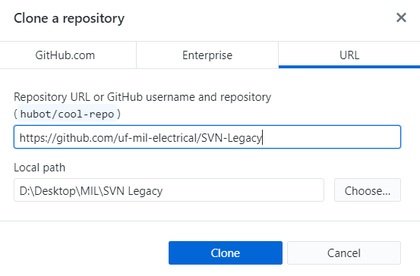

This may take some time the first time. This is normal

Step 3) Check Repo for Updates
- In general, it is important that before doing any major work in any version control repo, that you check for any updates that users might have made. If you do not, then more extensive effort needs to merge the changes. In some extreme cases, the repository may even be broken and must be updated to an earlier revision and current work may be lost.

- You can check the repo for updates by clicking “Fetch origin” on the top right of the GitHub desktop application.

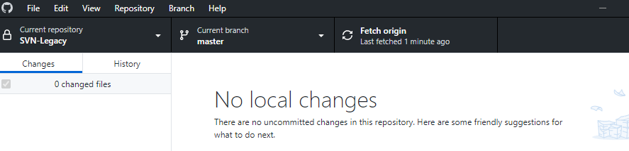

Step 4) Pushing your changes
The GitHub site does a good job of explaining how to push your changes so I will just reference that here. Note: unless specified you should be working in the master branch.

Link: https://help.github.com/en/desktop/contributing-to-projects/committing-and-reviewing-changes-to-your-project

If the link does not work anymore, please reference the GitHelp directory of your project for some info.

Step 5) Continual work
You should be all set now. The workflow with version control is to update -> make changes -> commit changes. If you follow that. There should be no issues. Please ask for help when needed.

For more advanced GitHelp please check this link: https://help.github.com/en/desktop

